GRAPHTHEORY

Definitions and Examples
Informally, a graph is a diagram consisting of points, called vertices, joined together by lines, called edges; each edge joins exactly two vertices. A graph G is a triple consisting of a vertex set of V(G), an edge set E(G), and a relation that associates with each edge two vertices (not necessarily distinct) called its endpoints.
Definition of Graph
A graph G = (V, E) consists of a (finite) set denoted by V, or by V(G) if one wishes to make clear which graph is under consideration, and a collection E, or E(G), of unordered pairs {u, v} of distinct elements from V. Each element of V is called a vertex or a point or a node, and each element of E is called an edge or a line or a link. Formally , a graph G is an ordered pair of dsjoint sets (V, E), where E ⊆ V × V. Set V is called the vertex or node set, while set E is the edge set of graph G. Typically, it is assumed that self-loops (i.e. edges of the form (u, u), for some u ∈ V) are not contained in a graph.
Directed and Undirected Graph
A graph G = (V, E) is directed if the edge set is composed of ordered vertex (node) pairs. A graph is undirected if the edge set is composed of unordered vertex pair.
Vertex Cardinality The number of vertices, the cardinality of V, is called the order of graph and devoted by |V|. We usually use n to denote the order of G. The number of edges, the cardinality of E, is called the size of graph and denoted by |E|. We usually use m to denote the size of G.
Neighbor Vertex and Neighborhood We write v_{i}v_{j} ∈ E(G) to mean {v_{i}, v_{j}}∈ E(G), and if e = v_{i} v_{j} ∈ E(G), we say v_{i} and v_{j} are adjacent.
Formally, given a graph G = (V, E), two vertices v_{i} , v_{j} ∈ V are said to be neighbors, or adjacent nodes, if ( v_{i} , v_{j} ) ∈ E. If G is directed, we distinguish between incoming neighbors of v_{i} (those vertices v_{j} ∈ V such that (v_{j}, v_{i}) ∈ E) and outgoing neighbors of v_{i} (those vertices v_{j} ∈V such that (v_{i}, v_{j}) ∈ E).
Vertex Degree
The degree deg(v) of vertex v is the number of edges incident on v . The degree sequence of graph is (deg(v₁), deg(v₂), ..., deg(v_{n})), typically written in nondecreasing or nonincreasing order. The minimum and maximum degree of vertices in V(G) are denoted by δ(G) and ∆(G), respectively. If δ(G) = ∆(G) = r, then graph G is said to be regular of degree r, or simply r-regular.
Formally, given a graph G = (V, E), the degree of a vertex v ∈ V is the number of its neighbors in the graph. That is,
deg(v) = | {u ∈ V : (v, w) ∈ E}|.
If G is directed, we distinguish between in-degree (number of incoming neighbors) and out-degree (number of outgoing neighbors) of a vertex.
Loop and Multiple Edges
A loop is an edge whose endpoints are equal i.e., an edge joining a vertex to it self is called a loop. We say that the graph has multiple edges if in the graph two or more edges joining the same pair of vertices.

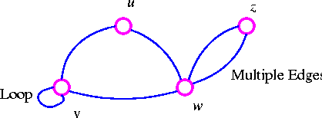

Simple Graph
A graph with no loops or multiple edges is called a simple graph. We specify a simple graph by its set of vertices and set of edges, treating the edge set as a set of unordered pairs of vertices and write e = uv (or e = vu) for an edge e with endpoints u and v.

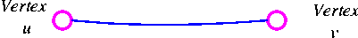

When u and v are endpoints of an edge, they are adjacent and are neighbors.
Connected Graph
A graph that is in one piece is said to be connected, whereas one which splits into several pieces is disconnected.

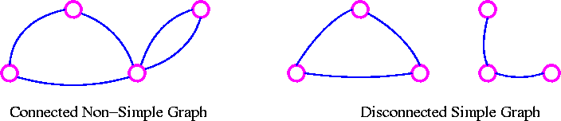
A graph G is connected if there is a path in G between any given pair of vertices, otherwise it is disconnected. Every disconnected graph can be split up into a number of connected subgraphs, called components.
Sub graph
Let G be a graph with vertex set V(G) and edge-list E(G). A subgraph of G is a graph all of whose vertices belong to V(G) and all of whose edges belong to E(G). For example, if G is the connected graph below:

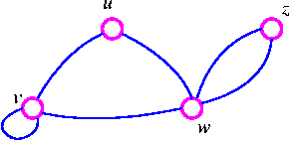

where V(G) = {u, v, w, z} and E(G) = (uv, uw, vv, vw, wz, wz} then the following four graphs are subgraphs of G.

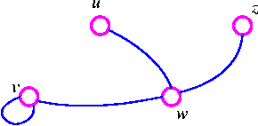

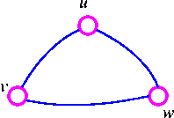

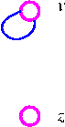
Degree (or Valency )
Let G be a graph with loops, and let v be a vertex of G. The degree of v is the number of edges meeting at v, and is denoted by deg(v).
For example, consider, the following graph G

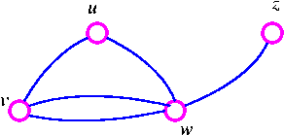

The graph G has deg(u) = 2, deg(v) = 3, deg(w) = 4 and deg(z) = 1.
Regular Graph
A graph is regular if all the vertices of G have the same degree. In particular, if the degree of each vertex is r, the G is regular of degree r.

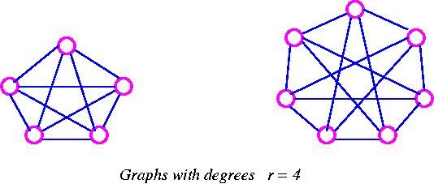

The Handshaking Lemma In any graph, the sum of all the vertex-degree is equal to twice the number of edges.
Proof Since each edge has two ends, it must contribute exactly 2 to the sum of the degrees. The result follows immediately.
The Following are the consequences of the Handshaking lemma.
- In any graph, the sum of all the vertex-degree is an even number.
- In any graph, the number of vertices of odd degree is even.
- If G is a graph which has n vertices and is regular of degree r, then G has exactly 1/2 nr edges.
Isomorphic Graphs
Two graph G and H are isomorphic if H can be obtained from G by relabeling the vertices - that is, if there is a one-to-one correspondence between the vertices of G and those of H, such that the number of edges joining any pair of vertices in G is equal to the number of edges joining the corresponding pair of vertices in H. For example, two unlabeled graphs, such as

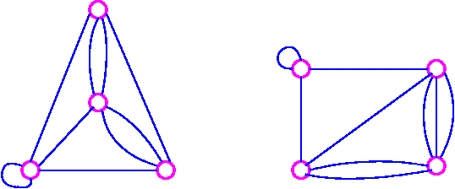
are isomorphic if labels can be attached to their vertices so that they become the same graph.

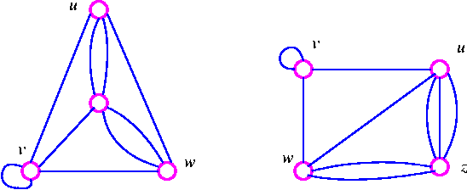
The word isomorphic derives from the Greek for same and form.
Walk A walk of length k in a graph G is a succession of k edges of G of the form uv, vw, wx, . . . , yz.
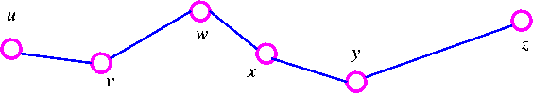

We denote this walk by uvwx . . yz and refer to it as a walk between u and z. Trail and Path :If all the edges (but no necessarily all the vertices) of a walk are different, then the walk is called a trail. If, in addition, all the vertices are difficult, then the trail is called path.
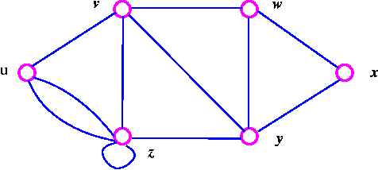

- The walk vzzywxy is a trail since the vertices y and z both occur twice.
- The walk vwxyz is a path since the walk has no repeated vertices.
Complete Graphs A computer graph is a graph in which every two distinct vertices are joined by exactly one edge. The complete graph with n vertices is denoted by K_{n}.The following are the examples of complete graphs.
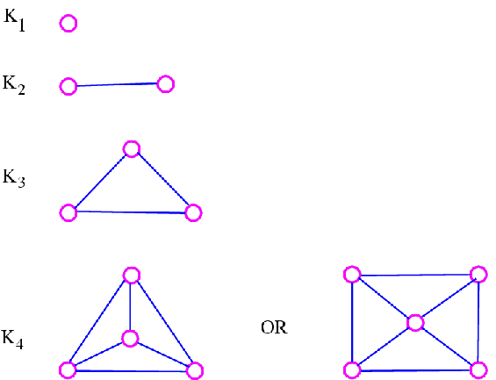
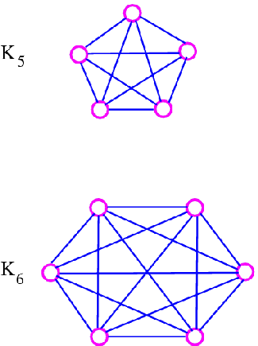
The graph K_{n} is regular of degree n-1, and therefore has 1/2n(n-1) edges, by consequence 3 of the handshaking lemma.
Null Graphs A null graphs is a graph containing no edges. The null graph with n vertices is denoted by N_{n}.The following are the examples of null graphs.

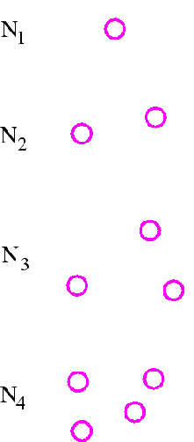
Note that N_{n} is regular of degree 0.
Cycle Graphs A cycle graph is a graph consisting of a single cycle. The cycle graph with n vertices is denoted by C_{n}.The following are the examples of cyclic graphs.

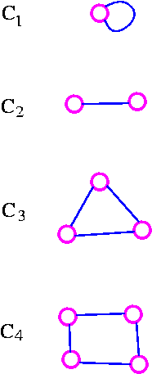
Note that C_{n} is regular of degree 2, and has n edges.
Path Graphs
A path graph is a graph consisting of a single path. The path graph with n vertices is denoted by P_{n}.
The following are the examples of path graphs.

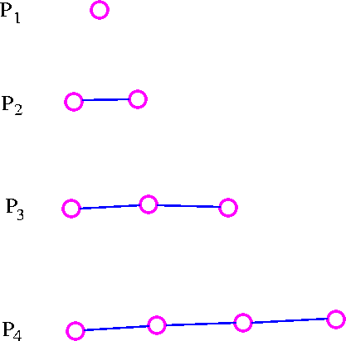

Note that path graph, P_{n}, has n-1 edges, and can be obtained from cycle graph, C_{n}, by removing any edge.
Bipartite Graphs
A bipartite graph is a graph whose vertex-set can be split into two sets in such a way that each edge of the graph joins a vertex in first set to a vertex in second set.
The examples of bipartite graphs are:
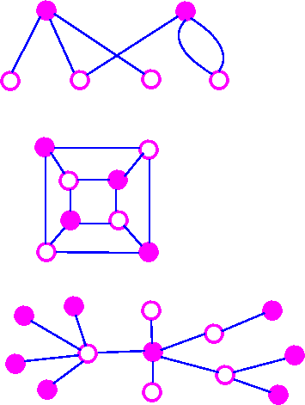

Complete Bipartite Graph
A complete bipartite graph is a bipartite graph in which each vertex in the first set is joined to each vertex in the second set by exactly one edge. The complete bipartite graph with r vertices and 3 vertices is denoted by K_{r,s}.
The following are some examples.
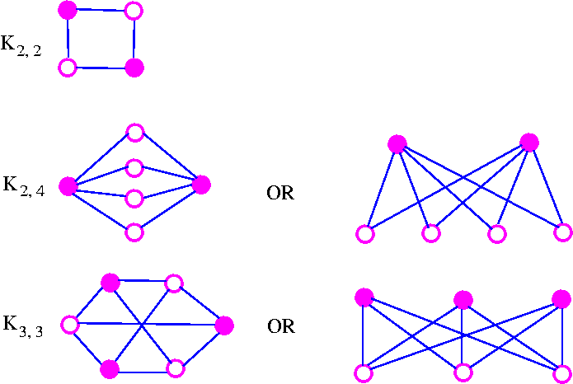

Note that K_{r,s} has r+s vertices (r vertices of degrees, and s vertices of degree r), and rs edges. Note also that K_{r,s} = K_{s,r}.
An Important Note: A complete bipartite graph of the form K_{r,s} is called a star graph.
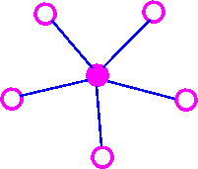

Cube Graph
The cube graphs is a bipartite graphs and have appropriate in the coding theory.
The cube graphs constructed by taking as vertices all binary words of a given length and joining two of these vertices if the corresponding binary words differ in just one place. The binary words of length k is called the k-cube (or k-dimensional cube) graph and is denoted by Q_{k}.
The following are some examples.

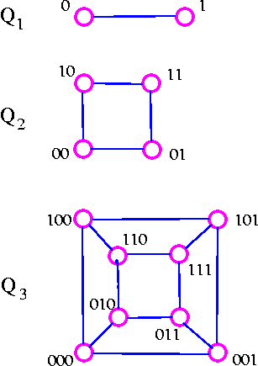

Note that Q_{k} has 2^{k} vertices and is regular of degree k. It follows from consequence 3 of the handshaking lemma that Q_{k} has k* 2^{k-1} edges.

The Peterson Graph
This graph is named after a Danish mathematician, Julius Peterson(1839-1910), who discovered the graph in a paper of 1898.

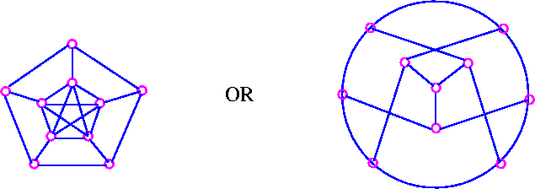

Tree Graph
A tree is a connected graph which has no cycles.
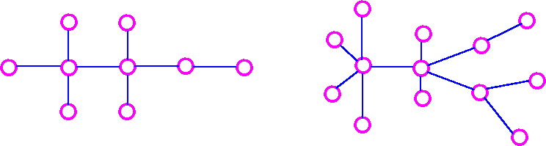

Spanning Tree If G is a connected graph, the spanning tree in G is a subgraph of G which includes every vertex of G and is also a tree.
Consider the following graph

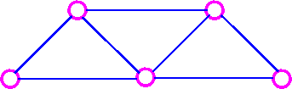

The following are the three of its spanning trees:

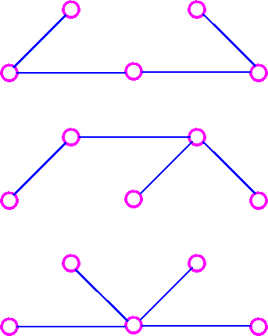

Definition of Diagraph
A directed graph or diagraph D consists of a set of elements, called vertices, and a list of ordered pairs of these elements, called arcs. The set of vertices is called arcs. The set of vertices is called the vertex-set of D, denoted by V(D), and the list of arcs is called the arc-list of D, denoted by A(D). If v and w are vertices of D, then an arc of the form vw is said to be directed from v to w, or to join v to w.

The underlying graph of diagraph is the graph obtained by replacing each arc of diagraph by corresponding (undirected) edge. For example, consider the following digraph
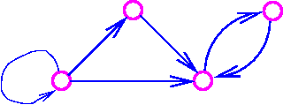
The underlying graph of the above digraph is
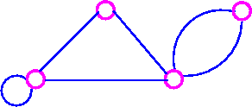

The Platonic Graphs
The following regular solids are called the Platonic solids:
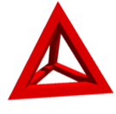
Tetrahedron

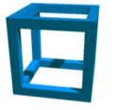
Hexahedron (cube)

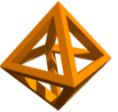
Octahedron


Dodecahedron

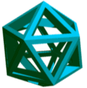
Icosahedron

The name Platonic arises from the fact that these five solids were mentioned in Plato's Timaeus. A Platonic graph is obtained by projecting the corresponding solid on to a plane.

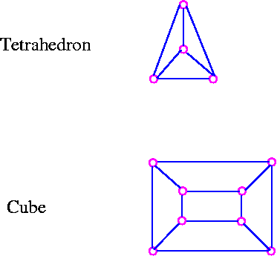
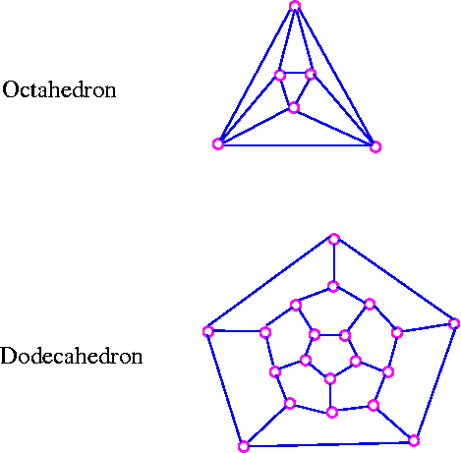
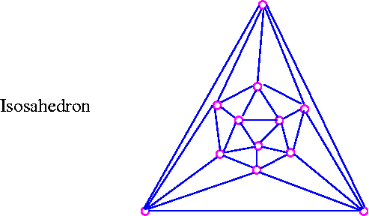

Connectivity
Bridge A bridge is a single edge whose removal disconnects a graph.

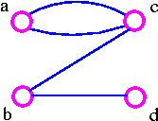

The above graph G1 can be split up into two components by removing one of the edges bc or bd. Therefore, edge bc or bd is a bridge.

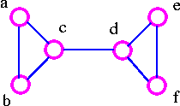

The above graph G2 can be disconnected by removing a single edge, cd. Therefore, edge cd is a bridge.

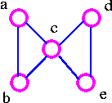

The above graph G3 cannot be disconnected by removing a single edge, but the removal of two edges (such as ac and bc) disconnects it.

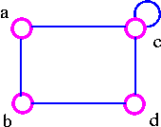

The above graph G4 can be disconnected by removing two edges such as ac and dc.
Edge Connectivity
The edge-connectivity λ(G) of a connected graph G is the smallest number of edges whose removal disconnects G. When λ(G) ≥ k, the graph G is said to be k-edge-connected.
For example, the edge connectivity of the above four graphs G1, G2, G3, and G4 are as follows:
- G1 has edge-connectivity 1.
- G2 has edge connectivity 1.
- G3 has edge connectivity 2.
- G4 has edge connectivity 2.
Cut Set
A cut set of a connected graph G is a set S of edges with the following properties
- The removal of all edges in S disconnects G.
- The removal of some (but not all) of edges in S does not disconnects G.

As an example consider the following graph

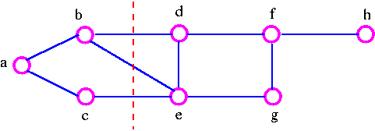

We can disconnect G by removing the three edges bd, bc, and ce, but we cannot disconnect it by removing just two of these edges. Note that a cut set is a set of edges in which no edge is redundant.
Vertex Connectivity
The connectivity (or vertex connectivity) K(G) of a connected graph G (other than a complete graph) is the minimum number of vertices whose removal disconnects G. When K(G) ≥ k, the graph is said to be k-connected (or k-vertex connected). When we remove a vertex, we must also remove the edges incident to it. As an example consider following graphs.

The above graph G can be disconnected by removal of single vertex (either b or c). The G has connectivity 1.

The above graph G can be disconnected by removal of single vertex (either c or d). The vertex c or d is a cut-vertex. The G has connectivity 1.
g46.gif
The above G can be disconnected by removing just one vertex i.e., vertex c. The vertex c is the cut-vertex. The G has connectivity 1.

The above G cannot be disconnected by removing a single vertex, but the removal of two non-adjacent vertices (such as b and c) disconnects it. The G has connectivity 2.
Cut-Vertex
A cut-vertex is a single vertex whose removal disconnects a graph.It is important to note that the above definition breaks down if G is a complete graph, since we cannot then disconnects G by removing vertices. Therefore, we make the following definition.
Connectivity of Complete GraphThe connectivity k(k_{n}) of the complete graph k_{n} is n-1. When n-1 ≥ k, the graph k_{n} is said to be k-connected.
Vertex-Cut set A vertex-cut set of a connected graph G is a set S of vertices with the following properties.
- the removal of all the vertices in S disconnects G.
- the removal of some (but not all) of vertices in S does not disconnects G.
Consider the following graph

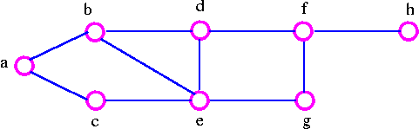

We can disconnects the graph by removing the two vertices b and e, but we cannot disconnect it by removing just one of these vertices. the vertex-cutset of G is {b, e}.
Note that the connectivity k(G) does not exceed the edge-connectivity λ(G). This inequality holds for all connected graph.
Formally, for any connected graph G we have
K(G) ≤ λ(G) ≤ δ(G)
where δ(G) is the smallest vertex-degree in G. But it is certainly possible for both inequality in above theorem to be strict inequalities (that is, k(G) < λ(G) < δ(G)) For example, in the following graph,

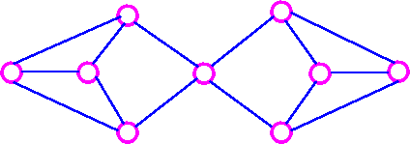
K(G)=1, λ(G) = 2, and δ(G) = 3.

Euler Graphs
Consider the following road map

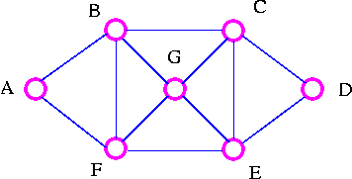

The explorer's Problem: An explorer wants to explore all the routes between a number of cities. Can a tour be found which traverses each route only once? Particularly, find a tour which starts at A, goes along each road exactly once, and ends back at A.
Examples of such tour are

A | B | C | D | E | F | B | G | C | E | G | F | A
A | F | G | C | D | E | G | B | C | E | F | B | A

The Explorer travels along each road (edges) just once but may visit a particular city (vertex) several times.
The Traveler's Problem
A traveler wants to visit a number of cities. Can a tour be found which visits each city only once? Particularly, find a tour which starts at A, goes to each city exactly once, and ends back at A.
Examples of such tour are

A | B | C | D | E | G | F | A
A | F | E | D | C | G | B | A

The travelers visits each city (vertex) just once but may omit several of the roads (edges) on the way.
Eulerian Trail
A connected graph G is Eulerian if there is a closed trail which includes every edge of G, such a trail is called an Eulerian trail.
Hamiltonian Cycle
A connected graph G is Hamiltonian if there is a cycle which includes every vertex of G; such a cycle is called a Hamiltonian cycle.
Consider the following examples:

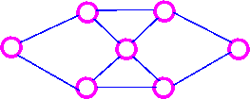
This graph is BOTH Eulerian and Hamiltonian.

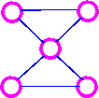
This graph is Eulerian, but NOT Hamiltonian.

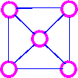
This graph is an Hamiltionian, but NOT Eulerian.

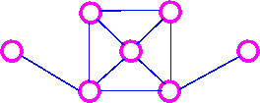
This graph is NEITHER Eulerian NOR Hamiltionian

Theorem Let G be a connected graph. Then G is Eulerian if and only if every vertex of G has even degree.
- Necessary Condition
  - If G is Eulerian, then every vertex of G has even degree.
- Sufficient Condition
  - If every vertex of G has even degree, then G is Eulerian. .
Neither necessary nor sufficient condition is known for a graph to be Hamiltonian. The search for necessary or sufficient conditions is a major area of study in graph theory today.
Sufficient Condition
Dirac's Theorem Let G be a simple graph with n vertices where n ≥ 3 If deg(v) ≥ 1/2 n for each vertex v, then G is Hamiltonian.
For example,
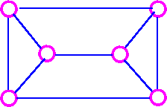

n = 6 and deg(v) = 3 for each vertex, so this graph is Hamiltonian by Dirac's theorem.

Ore's Theorem Let G be a simple graph with n vertices where n ≥ 2 if deg(v) + deg(w) ≥ n for each pair of non-adjacent vertices v and w, then G is Hamiltonian.
For example,

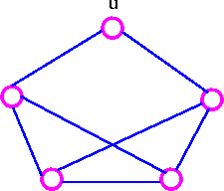

n = 5 but deg(u) = 2, so Dirac's theorem does not apply. However, deg(v) + deg(w) ≥ 5 for all pairs of vertices v and w (infact, for all pairs of vertices v and w), so this graph is Hamiltonian by Ore's theorem.
Note that if deg(v) ≥ 1/2 n for each vertex, then deg(v) + deg(w) ≥ n for each pair of vertices v and w. It follows that Dirac's theorem can be deduced from Ore's theorem, so we prove only Ore's threoem.

Trees

An acyclic graph (also known as a forest) is a graph with no cycles. A tree is a connected acyclic graph. Thus each component of a forest is tree, and any tree is a connected forest.
Theorem The following are equivalent in a graph G with n vertices.
- G is a tree.
- There is a unique path between every pair of vertices in G.
- G is connected, and every edge in G is a bridge.
- G is connected, and it has (n - 1) edges.
- G is acyclic, and it has (n - 1) edges.
- G is acyclic, and whenever any two arbitrary nonadjacent vertices in G are joined by and edge, the resulting enlarged graph G' has a unique cycle.
- G is connected, and whenever any two arbitrary nonadjacent vertices in G are joined by an edge, the resulting enlarged graph has a unique cycle.
Tree A tree is a connected graph which contain no cycles.
For example,

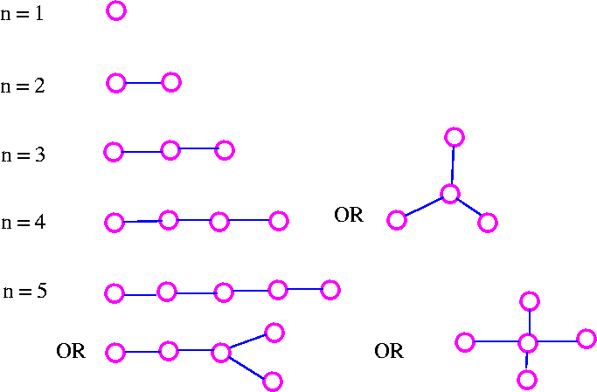

Theorem Let T be a graph with n vertices. Then the following statements are equivalent.
- T is connected and contains no cycles.
- T is connected and has n-1 edges.
- T has n-1 edges and contains no cycles.
- T is connected and each edge is a bridge.
- Any two vertices of T are connected by exactly one path.
- T contains no cycles, but the addition of any new edge creates exactly one cycles.
Spanning Trees
Let G be a connected graph. A spanning tree in G is a sub graph of G that includes all the vertices of G and is also a tree. The edges of the trees are called branches.For example, consider the following graph G

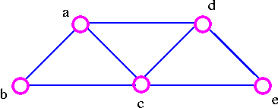
The three spanning trees G are:

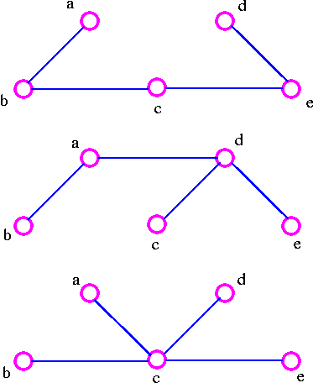
Theorem A graph is connected if and only if it has a spanning tree.
Proof Let G be a connected graph. Delete edges from G that are not bridges until we get a connected sub graph H in which each edge is a bridge. Then H is a spanning tree. On the other hand, if there is a spanning tree in G, there is a path between any pair of vertices in G; thus G is connected.
Graph Planarity
A graph G is planar if it can be drawn in the plane in such a way that no two edges meet each other except at a vertex to which they are incident. Any such drawing is called a plane drawing of G.
For example, the graph K₄ is planar, since it can be drawn in the plane without edges crossing.

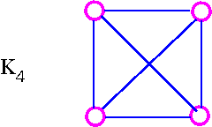

The three plane drawings of K₄ are:

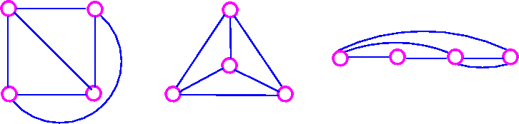

The five Platonic graphs are all planar.
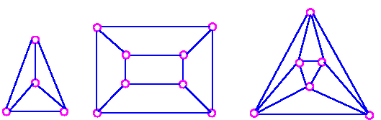
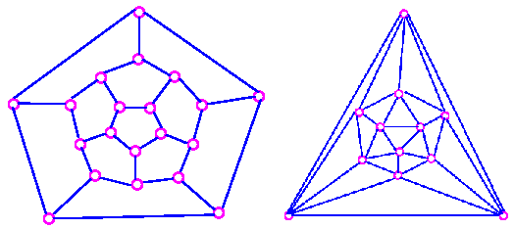

On the other hand, the complete bipartite graph K_{3,3} is not planar, since every drawing of K_{3,3} contains at least one crossing,cause K_{3,3} has a cycle which must appear in any plane drawing.
Euler's Formula
If G is a planar graph, then any plane drawing of G divides the plane into regions, called faces. One of these faces is unbounded, and is called the infinite face. If f is any face, then the degree of f (denoted by deg f) is the number of edges encountered in a walk around the boundary of the face f. If all faces have the same degree (g, say), the G is face-regular of degree g.
For example, the following graph G has four faces, f₄ being the infinite face.

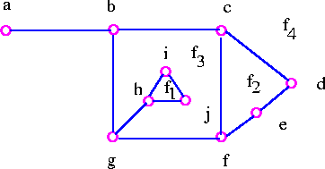

It is easy to see from above graph that deg f₁=3, deg f₂=4, deg f₃=9, deg f₄=8.

Note that the sum of all the degrees of the faces is equal to twice the number of edges in the the graph , since each edge either borders two different faces (such as bg, cd, and cf) or occurs twice when walk around a single face (such as ab and gh). The Euler's formula relates the number of vertices, edges and faces of a planar graph. If n, m, and f denote the number of vertices, edges, and faces respectively of a connected planar graph, then we get n-m+f = 2.
The Euler formula tells us that all plane drawings of a connected planar graph have the same number of faces namely, 2+m-n.

Theorem 1 (Euler's Formula) Let G be a connected planar graph, and let n, m and f denote, respectively, the numbers of vertices, edges, and faces in a plane drawing of G. Then n - m + f = 2.

Proof We employ mathematical induction on edges, m. The induction is obvious for m=0 since in this case n=1 and f=1. Assume that the result is true for all connected plane graphs with fewer than m edges, where m is greater than or equal to 1, and suppose that G has m edges. If G is a tree, then n=m+1 and f=1 so the desired formula follows. On the other hand, if G is not a tree, let e be a cycle edge of G and consider G-e. The connected plane graph G-e has n vertices, m-1 edges, and f-1 faces so that by the inductive hypothesis,
n - (m - 1) + (f - 1) = 2
which implies that n - m + f = 2.
Theorem 3 A graph is planar if and only if it does not contain a subdivision of K₅ and K_{3,3} as a subgraph.

